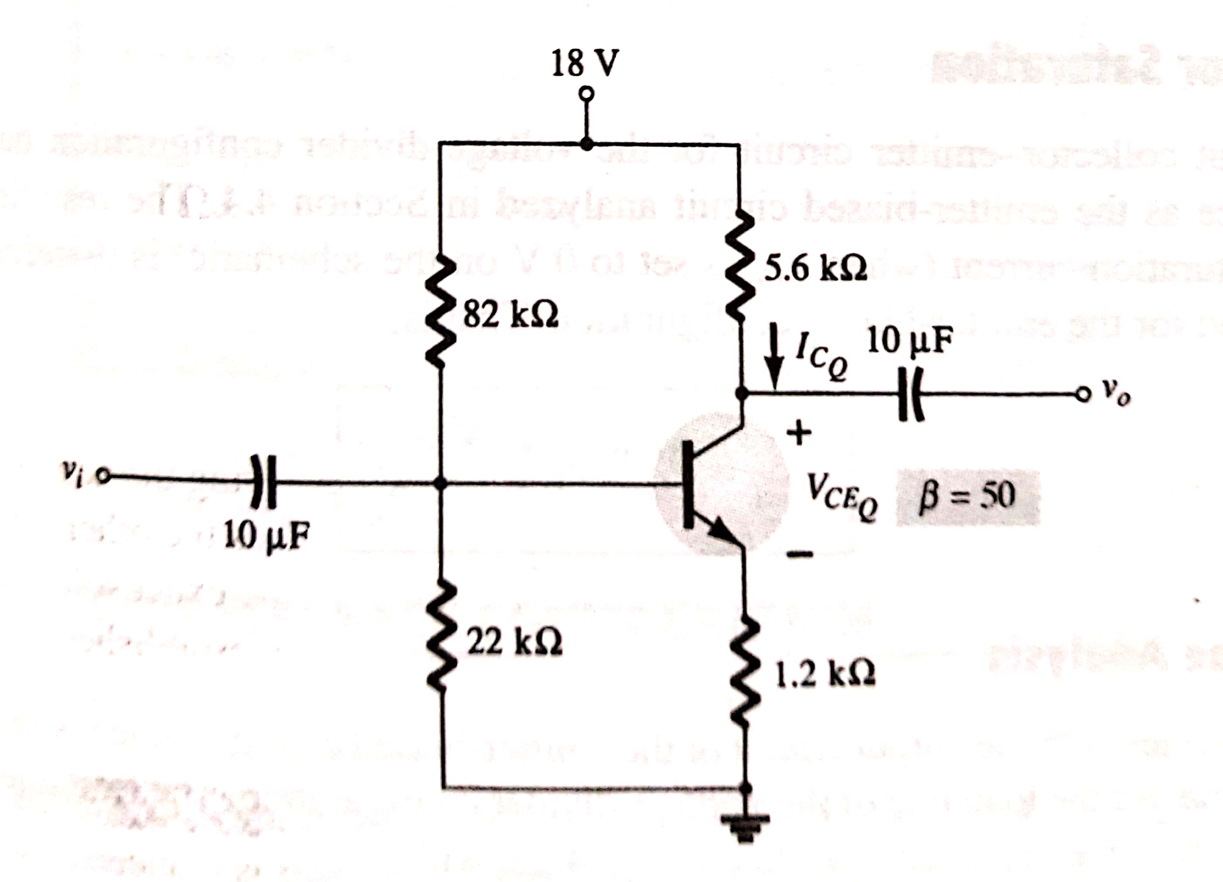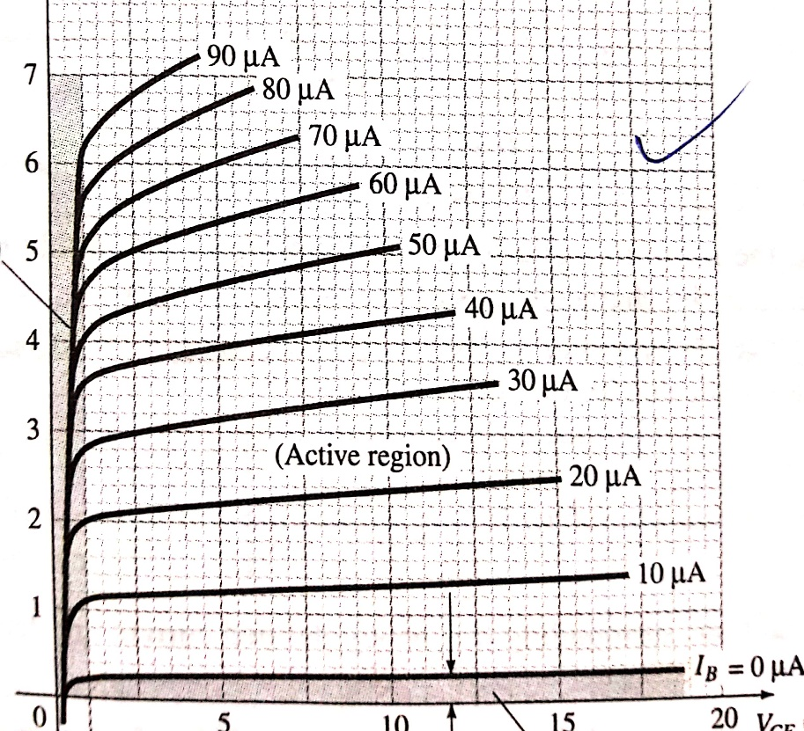

In the above figure draw a loadline corresponding to the circuit shown and find ICQ and VCEQ graphically.